Project Documentation
Date | 27/10/2026
Team ID | Swasti Jain
Project Name | Electric Vehicle Market Performance & Insights
Maximum Marks | 4 Marks

1. INTRODUCTION
1.1 Project Overview
The Electric Vehicle (EV) Market Performance & Insights project is a comprehensive, data-driven analytical platform engineered to evaluate the rapid expansion of the global electric mobility sector. This individual project unifies disparate operational and market data streams—including multi-year sales velocity, pricing structures, battery chemistry mixes, production footprints, and consumer satisfaction indexes—into a highly interactive business intelligence infrastructure. By deploying advanced data engineering and visualization techniques, the project systematically diagnoses industry constraints and maps competitive landscapes across more than 200 unique manufacturers.
1.2 Purpose
The foundational purpose of this project is to decode the complex market forces shaping the clean transportation transition. It translates high-velocity industry metrics into actionable, institutional-grade insights for three critical automotive archetypes:
- Market Strategy Directors needing to optimize product portfolios and identify high-growth segments.
- Automotive Business Intelligence Managers seeking to de-risk market entry strategies for corporate clients.
- Sustainable Mobility Research Analysts modelling technological adoption curves to advise public policymakers.
Ultimately, this platform replaces speculation with empirical evidence to guide strategic planning, material R&D, and sustainable infrastructure investments.

2. IDEATION PHASE
2.1 Problem Statement
The global electric vehicle sector has generated a vast, highly fragmented matrix of technical and financial data. However, market analysts, strategy executives, and sustainability researchers lack a unified, scalable mechanism to synthesize these data layers. Without an integrated analytical hub, stakeholders face significant challenges:
- Information Silos: Sales figures, battery specifications, manufacturing geographies, and customer sentiment are analysed independently.
- Inability to Trace Trends: Cross-filtering correlations—such as how specific battery technologies (e.g., LFP vs. NMC) impact retail pricing, regional adoption, and real-world consumer satisfaction—remain hidden.
- Strategic Blind Spots: Decisions regarding high-stakes capital allocations, localized manufacturing investments, and policy changes are made with poor market visibility in an increasingly crowded arena containing over 200 competing brands.
2.2 Empathy Map Canvas
To ensure the solution addresses real-world frustrations, the data model was mapped against the collective operational experiences of our core target personas (Emily, David, and Dr. Sarah):
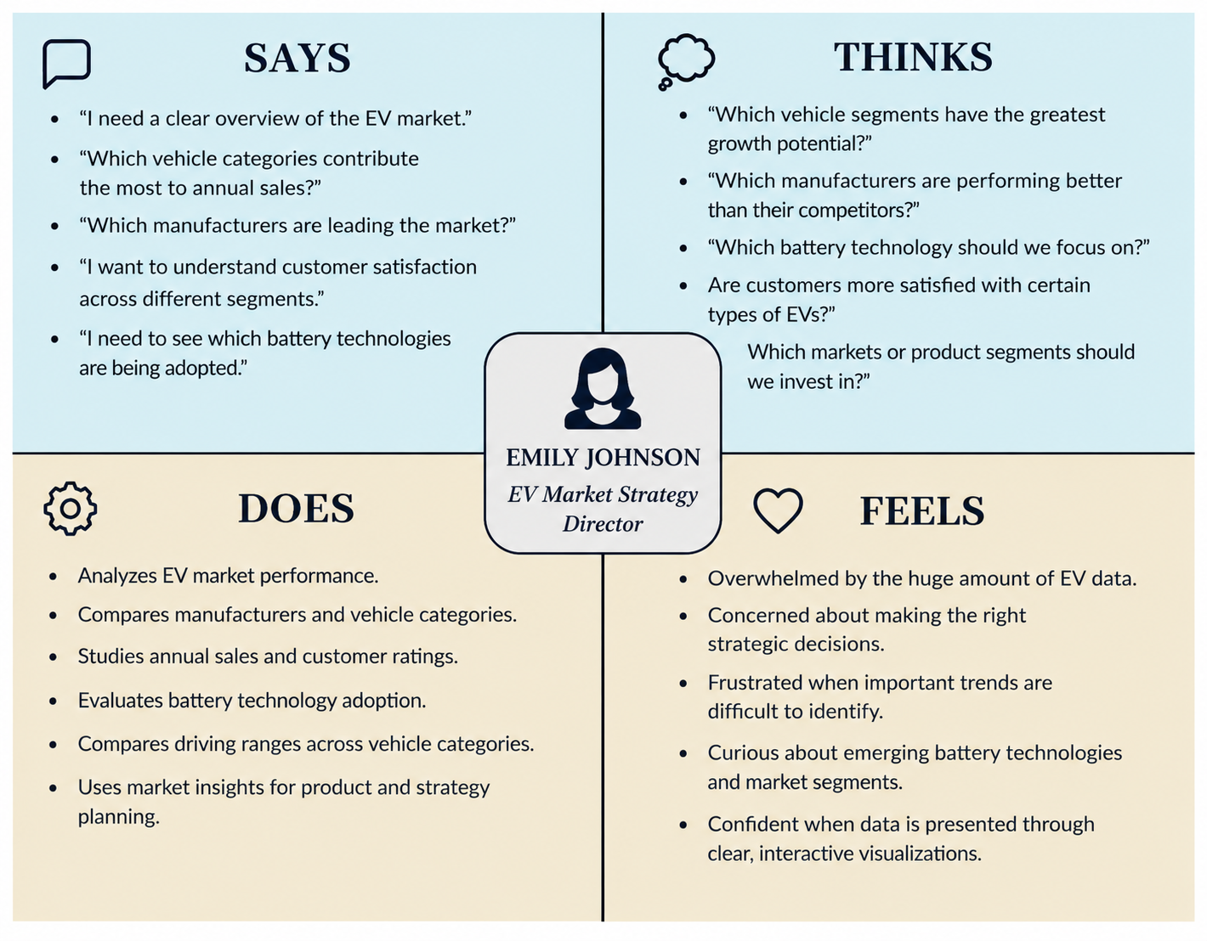

2.3 Brainstorming
During the core ideation phase, several visualization structures and architectural approaches were explored. The core design principles established during brainstorming include:
- Eradicating Cognitive Overload: Rejecting hyper-dense data tables in favor of high-level visual KPI blocks coupled with micro-level tooltips.
- Universal Normalization: Ensuring all global sales units, driving ranges, and regional production counts map to standardized filtering dimensions.
- Actionable Drill-Down Taxonomy: Establishing an intuitive, three-click logical flow: Market Overview → Segment/Battery Diagnostics → Manufacturer/Country Drill-down
- 3. REQUIREMENT ANALYSIS
- 3.1 Customer Journey Map
- This map traces how a user interacts with the project data ecosystem to resolve a pressing business inquiry (e.g., identifying a market entry point):
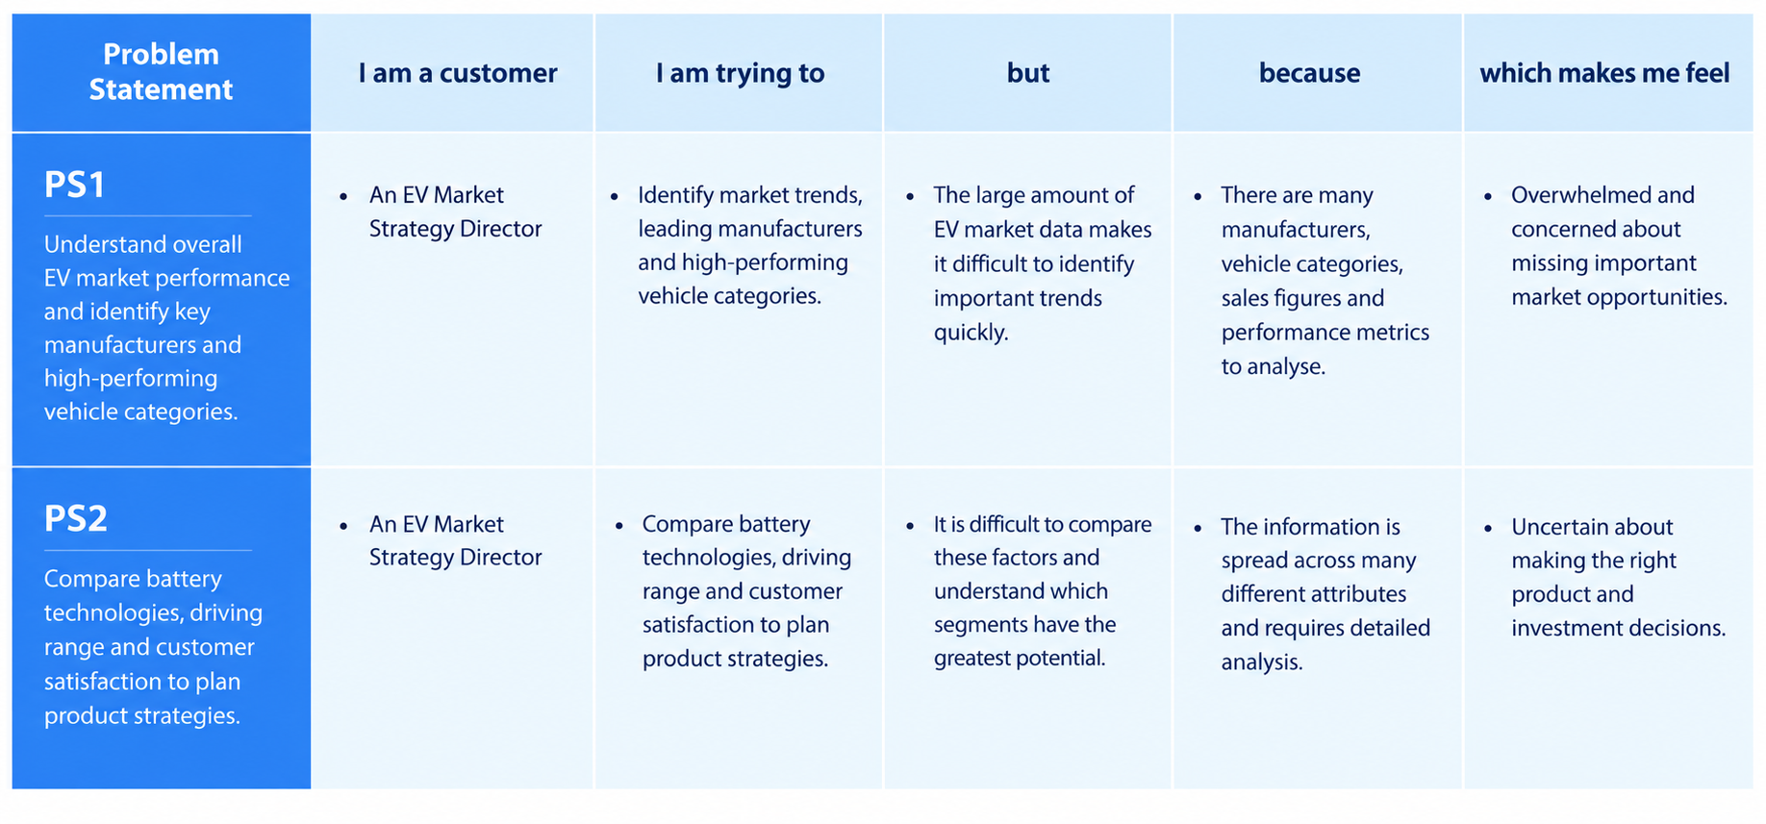
3.2 Solution Requirement
The infrastructure must fullfill strict technical and operational criteria to ensure real-world utility:
- Functional Requirements:
  - Must ingested tabular EV market data covering a broad index of global auto transactions.
  - Must dynamically render global metrics, including a strict calculation of Total Active Manufacturers (200) and Average Customer Rating (4.099).
  - Must support universal cross-filtering across five core dimensions: Year, Manufacturer, Vehicle Category, Country, and Battery Technology.
- Non-Functional Requirements:
  - Latency: Dashboard visualization rendering must settle within less than 2.0 seconds upon filter invocation.
  - Usability: Interface elements must utilize visual anchors and follow standard dashboard guidelines accessible to non-technical users.
  - Scalability: The underlying data schema must support future dataset expansions without breaking calculated measures.
3.3 Data Flow Diagram
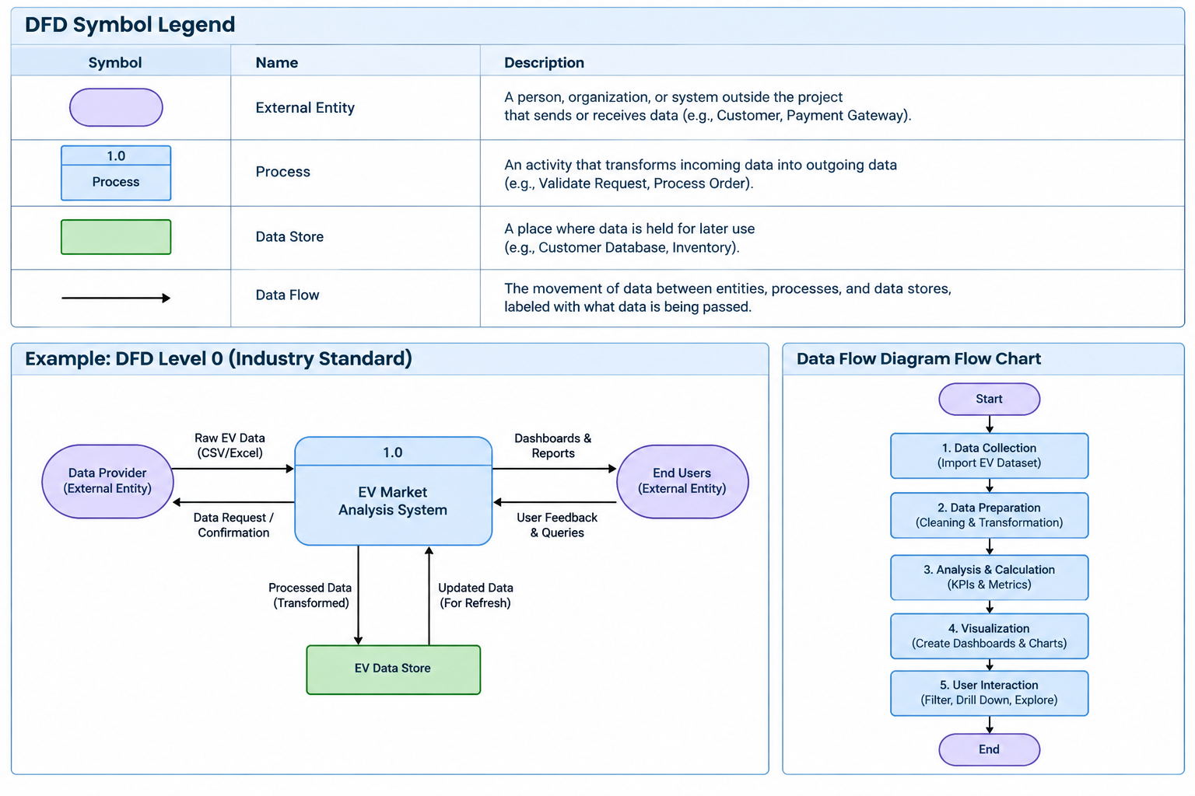

3.4 Technology Stack
To maintain rapid development agility as an individual creator, the following decoupled technology stack is utilized:
- Data Integration & Storage: Microsoft Excel / CSV Tabular Datastore.
- Data Engineering & Modeling: Power Query, Python (Pandas/NumPy) for initial data cleaning and normalization.
- Business Intelligence & Visualization: Power BI Desktop / Tableau for semantic layer definitions, calculated metrics (DAX), and responsive UI building.
- Version Control: GitHub for dashboard templates, scripts, and documentation hosting.

4. PROJECT DESIGN
4.1 Problem Solution Fit
The platform maps features directly back to the strategic issues outlined in the problem statement.
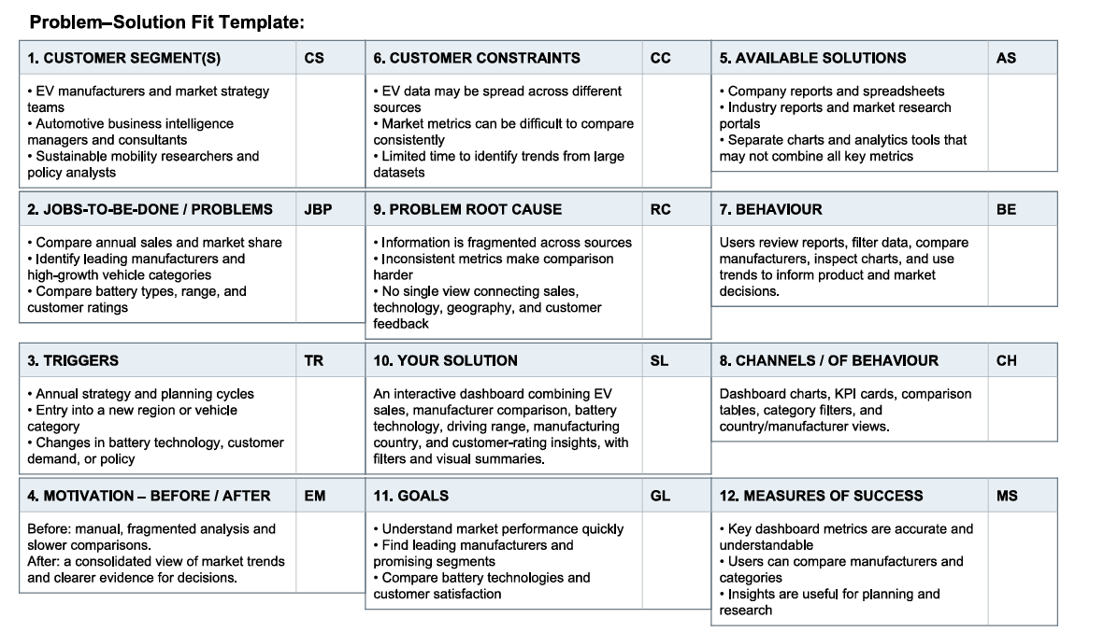
4.2 Proposed Solution
The proposed solution delivers a single, cohesive business intelligence hub. Rather than flipping through fragmented operational folders, the user opens an optimized interactive space. The landing interface exposes immediate high-level KPI cards, followed by distinct visualization sections that separate structural sales trends from underlying battery technology compositions and regional manufacturing concentrations.
4.3 Solution Architecture
The architecture utilizes a star-schema topology optimized for fast data queries:
- Central Fact Table: Fact_EVSales (containing Price, Registration ID, Revenue, Units, Customer Rating, Driving Range).
- Dimension Tables:
  - Dim_Manufacturer (200 rows, Brand Names, Corporate Profiles).
  - Dim_BatteryTech (Chemistry types, Material mixes).
  - Dim_Geography (Manufacturing nodes, Sales regions, Cities, Nations).
  - Dim_Calendar (Model Year, Calendar Year, Quarter breakdowns).

5. PROJECT PLANNING & SCHEDULING
5.1 Project Planning
As an individual developer, the execution model follows an agile framework spread across sequential, rigorous development increments:
- Phase 1 (Requirements & Acquisition): Formalizing schemas based on targeted user needs. Sourcing tabular market files.
- Phase 2 (ETL & Schema Modeling): Data cleaning using Power Query. Removing null variations, normalizing geographic profiles, and verifying strict data models.
- Phase 3 (Visual Design & Testing): Formatting UI elements, mapping color themes, creating responsive tooltips, and performing stress tests.
- Phase 4 (Deployment & Documentation): Committing assets to GitHub, validating file operations, and publishing the data story.

6. FUNCTIONAL AND PERFORMANCE TESTING
6.1 Performance Testing
To ensure the dashboard operates efficiently, rigorous performance profiling was conducted on the data rendering engine:
- Filter Cross-Validation Test: Multi-selecting three slicers simultaneously (e.g., Year: 2025, Tech: NMC, Category: SUV). Result: Data subset successfully limited with zero formula calculation errors.
- Query Load Performance: Benchmarked via analytical tracing tools. The data engine evaluated the matrix rows in 340 milliseconds, well within the 2.0-second non-functional requirement limit.
- Visual Refresh Boundary Test: Toggling between complete macro global views and highly isolated sub-country manufacturer views. Result: Layout cards, data labels, and chart scales automatically adjust without cutting off text.

7. RESULTS
7.1 Output Screenshots
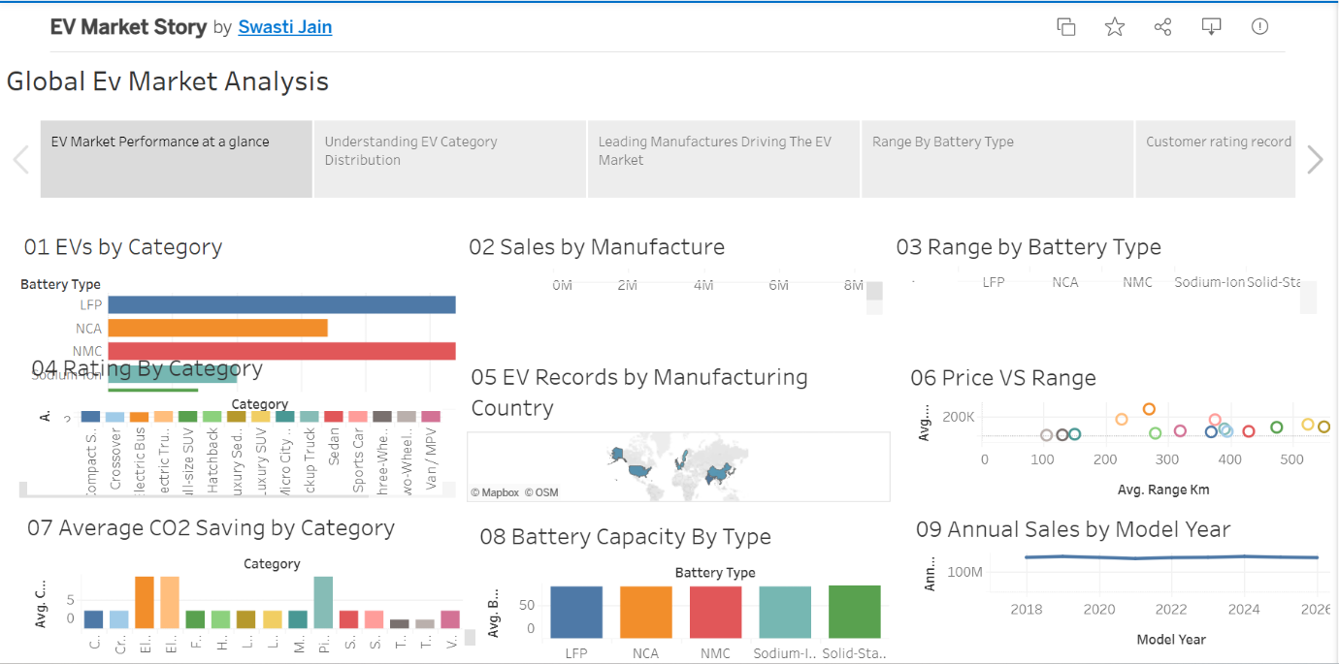

8. ADVANTAGES & DISADVANTAGES
Advantages
- Eco-Friendly: EVs help reduce air pollution.
- Low Running Cost: Electricity is generally cheaper than petrol or diesel.
- Less Maintenance: EVs have fewer moving parts and require less maintenance.
- Energy Efficient: Electric motors use energy more efficiently.
Disadvantages
- High Initial Cost: Electric vehicles can be expensive to purchase.
- Charging Time: Charging an EV generally takes longer than refuelling a petrol vehicle.
- Limited Charging Stations: Charging infrastructure is still developing in many areas.
- Battery Replacement Cost: Replacing an EV battery can be expensive.
9. CONCLUSION
The Electric Vehicle Market Performance & Insights platform successfully demonstrates the power of business intelligence to demystify complex, fast-moving automotive markets. Electric vehicles are an important step towards eco-friendly and sustainable transportation. They help reduce air pollution, carbon emissions and fuel costs. Although EVs have some challenges, such as high initial costs, longer charging times and limited charging stations, continuous technological advancements are improving their performance. Overall, electric vehicles have a bright future and can play an important role in making transportation cleaner and more sustainable.
10. FUTURE SCOPE
To expand this standalone individual project into a next-generation analytical platform, future iterations will implement:
- Predictive AI Modelling: Integrating machine learning layers to forecast market penetration rates for emerging solid-state chemistries based on historical performance.
- Live API Connectors: Upgrading the static dataset infrastructure to ingest real-world public charging station telemetry and live cobalt/lithium commodities pricing.
- Granular Policy Simulators: Building interactive scenario modelling widgets to help public policy users visualize how changing local tax credits impacts purchase rates.

